**chapter-23**

**Trigonometry**

**Important Formulae**

**Trigonometric Ratios :**



(Hypotenous)2 = (Base)2 + (Perpendicular)2

(i) sin  = 

(ii) cos   = 

(iii) tan  = 

(iv) cosec  

(v) sec   

vi cot    

**Trigonometric Identies** : Following results hold for all values of  These results are called Trigonometric identities.

(i) 

(ii) 

(iii) 1 + cot2  = cosec2 

**Remark :** We have (i) tan  

(ii) cot  

iii tan  × cot  = 1

**Complementary angles :** The angles  and (90-) are called complementary angles.

Results on complementary angles:

(i) sin (900- ) = cos 

(ii) cos (900- ) = sin 

(iii) tan (900- ) = cot 

(iv) cosec (900- ) = sec 

(v) sec (900- ) = cosec 

(vi) cot (900- ) = tan 

**Value of trigonometric ratios** -

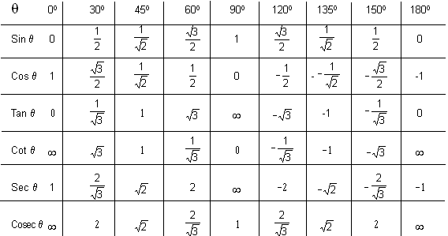

**Some fomulas:**

1. Sin(A + B) = sin A cos B + cos A sin B

2. sin (A-B) = sin A cos B - cos A sin B

3. cos (A + B) = cos A cos B - sin A sin B

4. cos (A-B) = cos A cos B + sin A sin B

5. tan (A-B) 

6. tan (A+B) 

7. sin2 A = 2sin A cos A

8. cos2 A = cos2A -sin2 A

9. cos2 A = 1-2sin2A

10. cos2 A = 2cos2A-1

**Circular Measure**:- The unit of measurement of angles in this system is a radian (or 1c).

A radian is defined as the angle subtended at the centre of a circle by an arc whose length is equal to the radius of the circle and it is denoted by 1c.

In the figure PO = OQ = r, (radius of the circle) and 



Length of arc (L) =

**Maxima and Minima -**

Minima Maxima

sin , sin 2,sin3,....... –1 +1

sin n

cos , cos 2,cos 3,....... –1 +1

cos n

sin2 , sin2 2,sin23,....... 0 +1

sin2 n

cos2 , cos2 2,cos2 3,...... 0 +1

cos2 n

**Important formula for Maxima and Minima** -

(a sin  + b cos ) maxima value = 

(a sin  + b cos ) minima value =

(a tan  + b cot ) minima value =

**Example:**

**Answer:** 

**Example:** 

**Answer:** sin2 300 cos2 450 + 4 tan2 300 + sin2 900 –2 cos2 900.

= 



=

**Example:**. tan 350 tan 400 tan 450 tan 500 tan 550 = ?

**Answer:** tan 350 tan 400 tan 450 tan 500 tan 550

= tan 350 tan 400 ×1 × tan (90–400)× tan (90–350)

= tan 350 tan 400 × cot 400 ×cot 350

= (tan 350 cot 350)×(tan 400 × cot 400)

= 1×1 { tan  × cot  = 1} = 1

**Example:**  If tan  =and  is acute angle, then cosec   

**Answer:**



tan = 

In, ABC

AC = = 5

 cosec  =

**Example:** The least value of  is-

**Answer:** 4sec2 + 9 cosec2

= 4(1+tan2) + 9(1+cot2)

= 13+(4tan2 +9cot2)

Now, AM > GM

⇒ 

⇒ 4tan2 + 9cot2 > 2× > 12

 Minimum value of 4sec2 + 9 cosec2

= 13 + 12 = 25

**Example:**The value of 

is-

**Answer:** + 2 tan 11o tan 31o tan 45o. tan 59o tan 79o - 3 (sin2 21o + sin2 69o)

=  + 2 tan 11o. tan 790. tan 31o tan 59o - [sin2 21o + sin2 (90 - 21o)]

 + 2 tan 110 tan (900 - 31o) - 3(sin2 21o + cos2 21o)

= 1 + 2 (tan 11o cot 11o) tan 31o cot 31o) - 3

= 1 + 2 × × 1 - 3

= 1 + 2 - 3

= 3 - 3

= 0