[CHAPTER-24. HEIGHT & DISTANCE](http://www.sscguru.org/p/math-chapter-24-height-distance.html)

1. **Angle of Elevation:**

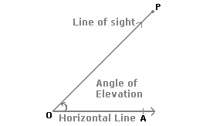

Suppose a man from a point O looks up at an object P, placed above the level of his eye. Then, the angle which the line of sight makes with the horizontal through O, is called the **angle of elevation** of P as seen from O.

* Angle of elevation of P from O = http://www.indiabix.com/_files/images/aptitude/1-sym-ang.gifAOP.

1. **Angle of Depression:**

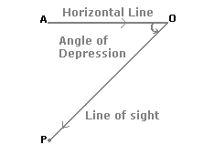

Suppose a man from a point O looks down at an object P, placed below the level of his eye, then the angle which the line of sight makes with the horizontal through O, is called the **angle of depression** of P as seen from O.

**Q.1.** The angle of elevation of a ladder leaning against a wall is 600 and the foot of the ladder is 7.5m away from the wall. The length of the ladder is-



**Ans.1.**

Let AB the ladder leaning against the wall CB. Let AC be the

horizontal such that AC = 7.5 m and CAB = 600.

sec 600=2, 

Length of the Ladder is 15 m.

**Q.2.** Two men are on opposite sides of a tower. They measure the angle of elevation of the top of the tower is 300 and 450 respectively height of the tower is 50m, find the distance between the two men.

**Ans.2.**

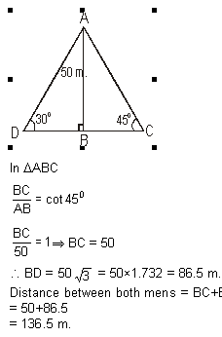

**Q.3.** The anlge of elevation of the top of a tower at a point on the ground is 300 on walking 20 metre towards the tower. The anlge of elevation becomes 600 . Find the height of the tower.

**Ans.**3.

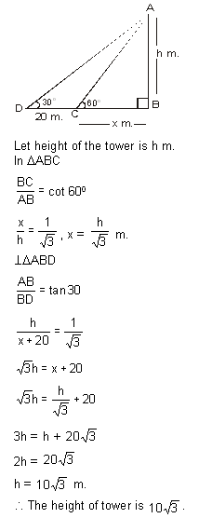

**Q.4.** From a point A on ground the angle of the elevation of the top tower is 450. If the tower is 136 m height. What is the distance of point A from the foot of tower ?

**Ans.4.**

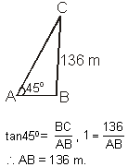

**Q.5.** From the top of the building 60 metre high, the angles of depression of the top and bottom of a tower are observed to be 30o and 60o. Find the height of the tower?

**Ans.5.**

