CHAPTER-21. COORDINATE GEOMETRY

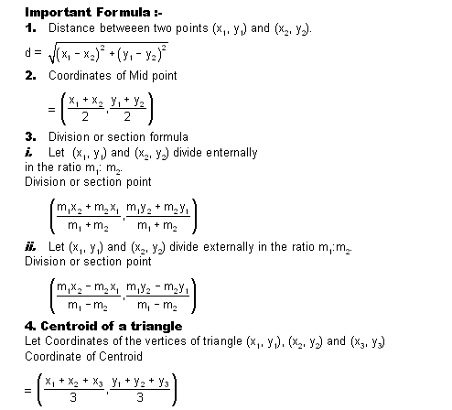

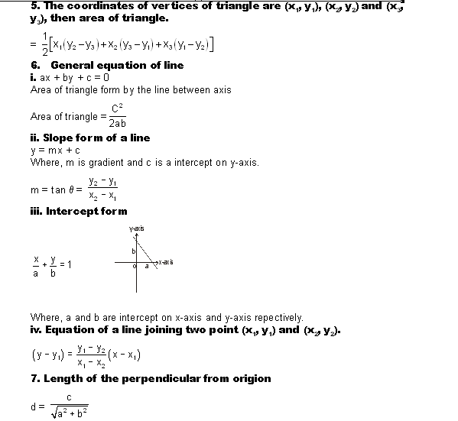

Q.1. The distance between the points (0, 0) and the intersecting point of the graphs of x = 3, and y = 4 is-
Ans.1.
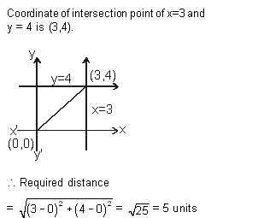
Q.2. The lines 2x + y = 5, and x + 2y = 4 intersect at the point-
Ans.2.

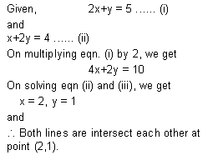
Q.3. The area of the traingle formed by the graph of ax + by = c, (where, a and b are two positive real numbers) and the coordinate axis is-
Ans.3.
