DIRECTION AND DISTANCE
In this chapter, the questions consist of a sort of direction puzzle. A successive follow-up of directions is formulated and the candidate is required to ascertain the final direction on the distance between two points.
This test is meant to judge the candidate’s ability to trace and follow correctly and sense the direction correctly.
There are four main directions:
North, East, South, West
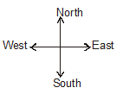
There are four subordinate directions:
North-East (N-E), South - East (S-E), South-West (S-W) & North-West (N-W) those are also called sub directions and these sub directions are between prime directions like NE is between North and East, SE is between South & East & so on,....
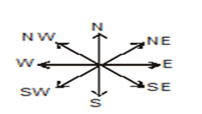
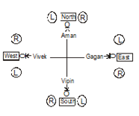
EXAMPLEs:

TYPE-1
Q.1. Shyam travels 7 km. toward North, then he turn to his right and walks 3 km. He again turns to his right and moves 7 km forward. Now in which direction is he from his starting point?
(1) North (2) South (3) East (4) West (5) Can’t be determined
EXPLANATION: Ans.3

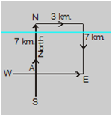
Q.2. Lucky walks 7 km. in the east. Then he turns to his right and moves 20 km, then he turns to his left and moves 5 km, then he turns to his left and moves 11 km. and then again he turned to his left and move 12 km. Now in which direction is he from his starting point and how far?
(1) 9 km South (2) 64 km East (3) 20 km west (4) 7 km south (5) None of these
EXPLANATION:
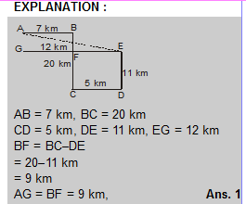

Type-2
Q.1. A man is facing North. He turns to 1800 in clockwise direction and another 450 in the same direction and the 2700 in the anticlockwise direction. Which direction is he facing now?
(1) South-West (2) South-East (3) North-East (4) North-West (5) North
EXPLANATION: Ans. 4
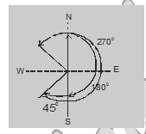
Final Direction North-West Degrees can only be judged towards the direction in which a person is facing instead of the path covered by him.

Type - 3
Q.1. One evening before sunset Rekha and Hema were talking to each other face to face. If Hema’s shadow was exactly to the right of Hema, which direction was Rekha facing?
(1) North (2) South (3) East (4) Data is inadequate (5) None of these
EXPLANATION: Ans. 2
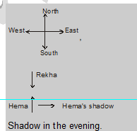
,

THANKS

