CHAPTER-2
CODING DECODING
Dear students,
In this chapter there are many types of coding and decoding questions. Before going into details let’s first know about what is meant by coding and decoding.
A code means arrangement of letters. Therefore coding is a method of transforming any instruction from the given form to the required form. The coding and decoding is an aid to check the candidate’s ability to understand the logic that codes a particular message to read the message.
CODING: A particular code pattern is used to express a word in English language to express it as a different word. The coded word itself does not make any sense unless we know the code, i.e. unless we know the pattern or code that has been followed.
DECODING: Decoding refers to the process of arriving at the equivalent English word from the code word given.

TYPES OF CODING
1. Letter coding
2. Number coding
3. Substitution coding
4. Sentence coding
5. Mathematical coding

1. Letter Coding
In these questions code values are given to a word in terms of letters.
Here, we have to analyze the pattern of the example and follow that pattern to find the answer.
- Take the given pair
- Write the position of all letters in given pair
- Try to find the relation between the letters of both part of pair
- Relation may be related to forward or backward order
- Implement the same relation on the given word for required answer
Possible relations on the basis of position of letters
in the given words may be-

(A)
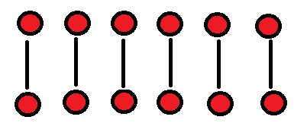
(B)
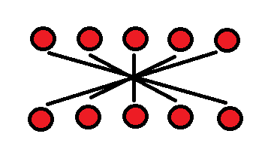
(C)
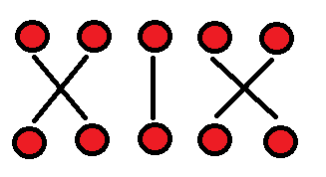
(D)
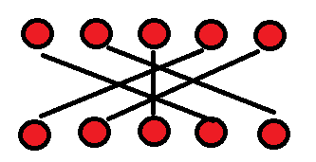
Etc………..
LOGICS WHICH CAN BE USED:
+1, +1, +1……….
-2, -2, -2 ………..
+1, -2, +3, -4, +5 …….
+4, -1, +4, -1, +4…….
Opp., +1, Opp., +1…..
Opp+1, Opp+1 …….
Opp+2, Opp+4, Opp+6………
Etc………………
EXAMPLE of letter coding -
Q.1. In a certain code language, teacher is written as VGCEJGT, then how will CHILDREN be written in that code language?
(1) ENAGITEV (2) PGTFNKJE (3) EJKNFTGP (4) MGAETVIE (5) None of these

EXPLANATION:
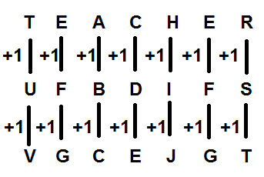
Similarly,
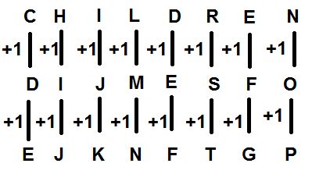
Hence answer is option (3).
Q.2. If light is coded as lJGIT, how is flames coded in that code?
(1) glbnet (2) fkaler (3) fmanet (4) glbmfs (5) None of these
EXPLANATION:
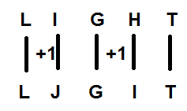
Similarly,
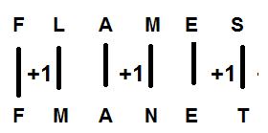
Hence, answer is option (3).
Q.3. If EQUITY is coded as SOCWIG and OUTPUT is coded as RSMRSN. How NOTIFY written in that code?
(1) LMRWDG (2) RMLGDW (3) RMLWGD (4) RMLWDG (5) None of these
EXPLANATION:
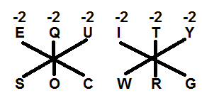
And
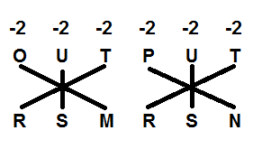
Similarly,
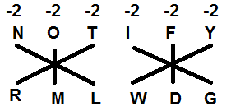
Hence answer is option (4).

2. Number Coding
In these questions, numerical code values are given to a word or vice- versa. The candidate is required to find the code depending upon the given coding pattern.
EXAMPLE OF NUMBER CODING
Q.1. In a certain code SISTER is coded as 535201, UNCLE is coded as 78960 How is NEER coded in that code?
(1) 8001 (2) 8901 (3) 8210 (4) 8100 (5) None of these
EXPLANATION:
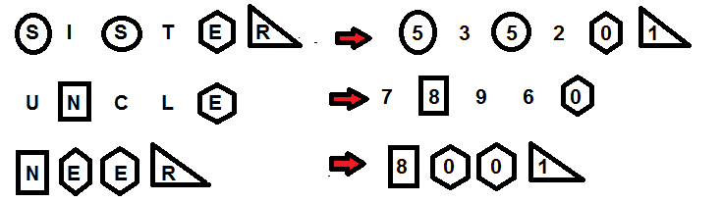
Hence answer is option (1).

Q.2. If REQUEST is written as S2R52TU, then how will ACID be written?
(1) 1D3F (2) 1D3E (3) 1DE3 (4) 1DF3
(5) 1D3G

EXPLANATION:
In this question, alternate letters are moved to next letter in alphabet series and vowels are written as their position in their own series.
RàS
Eà2 (A-1, E-2, I-3, O-4, U-5)
QàR
Uà5 (A-1, E-2, I-3, O-4, U-5)
Eà2 (A-1, E-2, I-3, O-4, U-5)
SàT
TàU
Similarly,
Aà1 (A-1, E-2, I-3, O-4, U-5)
CàD
Ià3 (A-1, E-2, I-3, O-4, U-5)
DàE
Means ACID will be coded as 1D3E. Hence answer is option (2).

Q.3. If ACTIVITY = 24315137, Then ELEPHANT =?
(1) 64263689 (2) 46892663 (3) 64689263 (4) 62468963 (5) 68926346
EXPLANATION:
It involves the position of alphabet in the alphabetic order + 1. If it becomes a single digit number, write it and if it is a two digit number then add it to get a single digit number as M’s place value is 13 it becomes 1+ 3 = 4. Similarly ELEPHANT => E = 5 + 1 = 6, L = 12 +1 = 13 => 1 + 3 = 4, E = 5 + 1 =6, P = 16 + 1 = 17 => 1 + 7 = 8 and so on. The code will become 64689263. Hence answer is option (3).

3. Substitution Coding
In this type of questions, a particular word is assigned a certain substituted name and a question is asked to be given in that substituted name.
EXAMPLE OF SUBSTITUTION CODIND
Q.1. If ‘eye’ is called ‘hand’, ‘hand’ is called ‘mouth’, ‘mouth’ is called ‘ear’, ‘ear’ is called ‘nose’, and ‘nose’ is called ‘tongue’. With which of the following would a person hear?
(1) eye (2) mouth (3) nose (4) ear (5) tongue
EXPLANATION:
Here answer should have been ear which is coded with nose. Hence answer is option (3).
Q.2. If sky is star, star is cloud, cloud is earth, earth is tree and tree is book, then where do the birds fly?
(1) Star (2) Sky (3) Cloud (4) Earth s (5) None of these
EXPLANATION:
We know that in reality birds fly in the sky but in this question, as given sky is called star. So star (option no. 1) is the answer.

4. Sentence coding
In this type of questions, a group of words will be coded.
EXAMPLE OF SENTENCE CODIND
Q.1. If ‘drink fruit juice’ is written as ‘tee see pee’, ‘juice is sweet’ is written as ‘see kee lee’ and ‘he is intelligent is written as ‘lee ree mee’. What will be the code for ‘sweet’ in that code language?
(1) see (2) kee (3) lee (4) pee (5) tee
EXPLANATION:
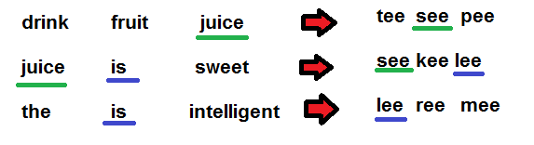
is ------- lee
juice ------- see
Hence ‘kee’ is answer.
Because in first and second step we get the code of ‘juice’ which is ‘see’. In the same manner from second and third step we get the code of ‘is’ which is ‘lee’. In the second step, the remaining word is “sweet” and the remaining code is “kee”
Therefore, answer is option (2).

Q.2. Some words are coded in a certain code language which is illustrated as:
‘you are nice’ is written as ‘na pa sa’, ‘mohan and you’ is written as ‘sa re ga’, ‘are mohan nice’ is written as ‘re na pa’, ‘mohan nice than radha’ is written as ‘da na re le’ and ‘radha you are nice’ is written as ‘sa pa da na’.
Q.1. How will ‘nice radha’ be written in that code language?
(1) da pa (2) na da (3) sa re (4) pa na
(5) None of these
EXPLANATION: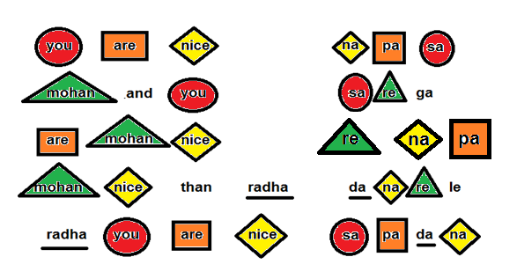
Hence answer is option (2).

5. Mathematical coding
In this type of questions, some letters or words are coded in a mathematical sign. And apply BODMAS trick to solve such
questions.
EXAMPLE OF MATHEMATICAL CODING
Q.1. If ‘M’ denotes ‘÷’, 'K' denotes ‘–’, ‘T’ denotes ‘×’ and ‘R’ denotes ‘+’, then-
40 K 18 T 6 M 2 R 8 =?
(1) 2 (2) -4 (3) 4 (4) 12 (5) None of these
EXPALNATION:
Q.1. (5) 40 K 18 T 6 M 2 R 8 =?
40 - 18 × 6 ÷ 2 + 8 =?
40 - 54 + 8 =?
? = 48 - 54
= - 6
Q.2-3.
In a certain instruction system the different computation processes are written as follows.
(i) A * B # C means A is multiplied by the sum of B and C.
(ii) AB  C means B is divided by C and the resultant is added to the square of A.
(iii) A @ B © C means C is subtracted from the product of A and B.
(iv) A%B C means C is subtracted from B and the resultant is added to A.
In each of the following question a set of instruction sequence is given. You are required to find out the outcome which should come in place of the question mark (?) in each of the given sets of sequence.

Q.2. m 16  2 =33
m %284 =?

(1) 19 (2) 29 (3) 39
(4) 5 (5) 29 or 19

EXPLANATION:

Q.2.(5) I, m2 = 25, m = 5
If m = +5, m = 29
If m = -5, m = 19

Q.3. 16 * x # 3 = 320
3 @ x © 4 =?

(1) 74 (2) 17 (3) 37
(4) 47 (5) None of these
EXPLANATION:

Q.3. (4) 16 × (x +3) = 320
x + 3 = 20
x = 17
(3 × 17) - 4 = 51 - 4 = 47

THANKS

